Thesis Plan
Submission: Find the submission link on Blackboard

Due date: The Thesis Plan must be submitted between Weeks 2 and 4 in the second semester (Part B).

Multiple submissions: The assessment is Pass/fail and you can submit multiple times. Submissions will be marked within three days, with feedback provided. Resubmissions are permitted before the due date, and multiple submissions are allowed within the submission window. It is strongly recommended that your initial submission is made well before the final deadline.

Hurdle: You must have submitted a satisfactory Thesis Plan by the final deadline (Friday of week 4) to satisfy the hurdle requirement. To receive a grade of 5 or higher for the Thesis Report, you must complete a satisfactory Thesis Plan. If the Thesis Plan is not completed to a satisfactory standard by the final deadline, the maximum grade achievable for the Thesis Report will be capped at 4.

Administrative details
Student name
Student number
Program enrolment
Course enrolment
Number of units
Expected workload for your enrolment (hours per week)

Supervision details
Primary Supervisor
Other Supervisors (optional)
Have you met your supervisor this semester (yes/no, online/in person)?
Do you have a regular meeting scheduled for this semester (weekly/biweekly/other (please specify))?

Thesis plan (thesis draft)
The Thesis Plan is an initial version of the final Thesis structure. Use the Word template or Latex template provided. Marking criteria focuses on appropriately filled in front matter, a contents page with section/chapter names, statement of AI use, and reuse of material from project proposal where possible. All background and related material should be appropriately referenced and appear in a bibliography/reference list.
It is normal for the thesis draft to vary from the submitted project proposal. Your final thesis may be different from your submitted draft thesis.
It is not considered plagiarism to use material from your previously submitted thesis works (including identical sentences). However, you should update it to describe what was actually achieved (not what was planned at the start of the project).

Use of AI Statement
Read and acknowledge the Use of AI Statement, describe the specific ways that you used AI in the assessment and fill in the AI table. Keep a record of this information over the year as you will need to update it for your proposal and final thesis report.
I acknowledge the use of generative AI tools in completing this assessment. Details of which tools were used and how they were used are provided in the table below, along with appropriate in-text and full references. I take responsibility for critically evaluating and integrating the AI-generated content, and ensuring it adheres to academic integrity standards.

Have you used AI in your project
- To explore your topic? Yes/no Explain how (or explain why not)
- To define your research question, explain how (or explain why not)
- To assist with your literature review, explain how (or explain why not)
- To assist with formatting the thesis outline presented here (e.g. grammar, spelling, language) Explain how (or explain why not)
- Did you generate figures using AI? Explain how (or explain why not)
- Did you analyse data using AI? Explain how (or explain why not)
- Did you generate data using AI? Explain how (or explain why not)
- Did you generate text for your thesis using AI? Explain how (or explain why not)
- For other aspects of your work? Explain how you used it. (e.g., Did you use generative AI to write your application for ethics approval?)
Fill in the table in the AI Use section below.



{Your Thesis Title}

by
{Author’s Name}

School of Electrical Engineering and Computer Science
The University of Queensland.

Submitted for the degree of {Your Program} as part of the course {Course Code e.g. REIT4841}.

Date of Submission
How to Use this Template
Title Page
- Replace text enclosed in curly brackets { } with your own content.
- The thesis title should be formatted in sentence case (i.e. only the first word and proper nouns should be capitalised).
- Present your name as it appears in your official UQ MySI-net record.
- Include the year and month of submission (day is not required).
- The UQ logo provided on the Title Page has been approved by UQ for use in theses. Please do not change the size of the logo.
- Please do not add any other content or change the formatting of the Title Page.
Preliminary Pages
- Do not modify the wording or format of any headings on the preliminary pages.
- Retain all headings in the order provided in this template.
- Replace text enclosed in curly brackets { } with your own content.
- Delete or replace any instructional text (displayed in purple) before submitting your thesis.
Thesis Content Pages
- The remainder of the template starting with ‘Table of Contents’ is offered as guidance only and is not intended to be prescriptive. You may adapt it to suit the specific requirements and conventions of your discipline. The layout in this example is Theory, Methods, Study 1, Study2, Study 3 but this may not suit your project! You can change these sections to whatever you need.
- The content pages that follow the preliminary pages are formatted using Microsoft Styles with embedded auto-numbering for chapters and headings. Page numbers have been incorporated to enable the automatic generation of the Table of Contents, as well as lists of tables and figures.
- Following publishing conventions, this template uses Roman numerals for the preliminary pages and Arabic numerals for the main body. Adjust the numbering as required by your discipline; however, please ensure that the title page does not display a page number.
- If you include blank pages in your thesis, please mark the page with: “This page was intentionally left blank.”

{Your Name}
{Your student email address}

{Date of Submission}

Prof Michael Brünig,
Head of School
School of Electrical Engineering and Computer Science
The University of Queensland
St Lucia QLD 4072

Dear Professor Brünig,
In accordance with the requirements of the Degree of {Bachelor of Engineering (Honours)} in the School of Electrical Engineering and Computer Science, I submit the following thesis entitled
“{Title of thesis}”
The thesis was performed under the supervision of {Supervisor’s Title and Full Name}. I declare that the work submitted in the thesis is my own, except as acknowledged in the text and footnotes, and that it has not previously been submitted for a degree at the University of Queensland or any other institution.

Yours sincerely

{Your name}

Declaration by Author
This thesis is composed of my original work, and contains no material previously published, written by another person, or generated by artificial intelligence (AI), except where clearly referenced and acknowledged either in the main text or the preliminary pages of this thesis. I have clearly stated the contribution of others to jointly authored works that I have included in my thesis.
I have clearly stated the contribution of others to my thesis as a whole, including statistical assistance, survey design, data analysis, significant technical procedures, professional editorial advice, use of AI tools, financial support and any other original research work used or reported in my thesis. The content of my thesis is the result of work I have carried out since the commencement of my enrolment in the course code indicated on the title page and does not include a substantial part of work that has been submitted to qualify for the award of any other degree or diploma in any university or other tertiary institution. I have clearly stated which parts of my thesis, if any, have been submitted to qualify for another award.
I acknowledge that copyright of all material contained in my thesis resides with the copyright holder(s) of that material. Where appropriate I have obtained copyright permission from the copyright holder to reproduce material in this thesis and have sought permission from co-authors for any jointly authored works included in the thesis.

Use of AI Statement
Use the statement and Table below to declare your AI use, or if you have not used any AI delete these and write a statement to that effect.

I acknowledge the use of generative AI tools in completing this assignment. Details of which tools were used and how they were used are provided in the table below, along with appropriate in-text and full references. I take responsibility for critically evaluating and integrating the AI-generated content, and ensuring it adheres to academic integrity standards.

AI Model and date(s) | Table A1. Artificial Intelligence (AI) tool usage (tick all that apply)
 | Language Translation | Grammer / style / spelling | Topic exploration | Research question | Literature review | Analyze data | Generate data | Generate text | Content Creation visual (formatting) | Content Creation (e.g. code) | Feedback | Other (provide details)
ChatGTP 4o
Weeks 5-6
Midjourney
1/09/2025 – 5/9/2025

Use your answers to the questions at the start of the assessment above to craft a paragraph specifically addressing how you used AI in the thesis. Details specific to your thesis matter.

Acknowledgments
Acknowledge your supervisor(s), preferably with a few short and specific statements about their contribution to the content and direction of the project. If you collaborated with another student, acknowledge your partner's contribution, including any parts of the thesis of which s/he was the principal author or co-author; this information can be duplicated in footnotes to the chapters or sections to which your partner has contributed. Briefly describe any assistance that you received from technical or administrative staff. Support of family and friends may also be acknowledged but generally sentimentality is avoided or hidden in the dedication.
Acknowledge any funding received (e.g., if the project is funded in part by a research grant or industry partner).

Abstract
This document is a skeleton thesis for 4th-year students. The notes and instructional text are displayed in purple and are meant to be informative but not necessarily illustrative; for example, this paragraph is not really an abstract, because it contains information not found elsewhere in the document. The LATEX 2ε source file (skel.tex) contains some non-printing comments giving additional information for students who wish to typeset their theses in LATEX. You can download the source, edit out the unwanted material, insert your own frontmatter and bibliographic entries, and in-line or \include{} your own chapter files. Of course, the content of a particular thesis will largely influence the form. Hence this document should not be seen as an attempt to force every thesis into the same mold. If in doubt about the structure of your thesis, seek advice from your supervisor.

Contents
Declaration by Author iv
Use of AI Statement v
Acknowledgments vi
Abstract vii
List of Figures (optional) ix
List of Tables (optional) ix
1. Introduction 1
1.1 Sub-heading as required 1
1.2 Sub-heading as required 1
2. Literature Review 2
2.1 Sub-heading as required 2
3. Theory 3
3.1 Sub-heading as required 3
3.2 Sub-heading as required 3
4. Methodology 5
4.1 Sub-heading as required 5
4.2 Sub-heading as required 5
5. Study 1 – Change this title! 6
5.1 Aims 6
5.2 Methods 6
5.3 Results 6
5.4 Discussion 6
6. Study 2- Change this title! 7
6.1 Aims 7
6.2 Methods 7
6.3 Results 7
6.4 Discussion 7
7. General Discussion and Conclusions 8
7.1 Summary 8
7.2 Discussion 8
7.3 Conclusions 8
7.4 Future Word 8
References 9
Appendix A 10

List of Figures (optional)

List of Tables (optional)

- Introduction
The introductory chapter describes the importance of the field and the scope and significance of your project. It usually ends with an overview of the remainder of the thesis.
Notice that Arabic page numbering begins with Chapter 1. Preceding pages (known as “frontmatter”) have Roman numbering. The book document class in LATEX follows this numbering convention by default (see Lamport [1], p. 80).
All of the material from your project proposal can be reused in this thesis. This is not considered plagiarism because you have permission to reuse the work in this way.

Sub-heading as required
You many want to use sub-headings here… you may not!

Sub-heading as required

- Literature Review
You will need to review previous work in the field, which may include books and papers (“literature”), patents and commercial products (“prior art”), and earlier work in your Department. This information is usually (but not always) collected in a single chapter, whose title should preferably be more specific and interesting than the one above. Use the literature review from your project proposal as a starting point. You will likely need to make some changes (e.g. adding additional references, paragraphs).

Sub-heading as required
You many want to use sub-headings here… you may not!

- Theory
A scientific paper is likely to be read by people who are not specialists in the same field as the author(s), but who nevertheless may need to use the results of the paper in their own fields. Similarly, the examiners of your thesis will probably include at least one academic who does not teach or conduct research in the subject area of your thesis. In an early chapter of your thesis, therefore, you should quote any theoretical results which are necessary for the understanding of later chapters. Examiners who are not specialists in your area will know whether you have given sufficient theoretical information. They will also know whether you have insulted their status by presenting material which is familiar to every half-competent graduate in every field of ECE.

Sub-heading as required
You many want to use sub-headings here… you may not!

Sub-heading as required
Theory sections often contain equations like the equation for the Fourier series of the function $f\left(x\right)$
 | $$f\left(x\right)=a_{0}+\sum_{n=1}^{∞}{\left(a_{n}\cos{\frac{nπx}{L}}+b_{n}\sin{\frac{nπx}{L}}\right)}$$ | ( 1)
where $a_{0}$ is the average value of the function, $a_{n}$ and $b_{n}$ are the coefficients for the $n$th harmonic …… etc

Equations in Word can be tricky, this one is set up in a 1x3 Table, and Word’s automatic Cross referencing feature is used to set up Equation numbering. It takes a minute to setup, but you can then refer to Equation ( 1) in text and Word will update the equation number automatically if you need to change it later.
Setting up automatic equation numbers in Word:
- Insert a 1×3 table (Insert → Table → 1×3).
- Left cell: leave empty (spacing)
- Middle cell: equation (centered)
- Right cell: equation number (right-aligned)
- In the middle cell, press Alt + = (Windows) or Control + = (Mac) to insert an equation.
- In the right cell, go to References → Insert Caption.
- Click “New Label…” and type ( (just the open parenthesis).
- Click “Numbering…” and choose the format (1, 2, 3…).
- After inserting, type ) manually after the number.
Format:
- Middle cell: center align.
- Right cell: right align.
- Remove table borders: Right-click → Table Properties → Borders and Shading → None.
- Adjust cell widths to keep equations centered.
Cross-referencing an equation number:
- Place your cursor where you want the reference in your text.
- Go to References → Cross-reference.
- In the “Reference type” dropdown, choose your custom label "(" (it will appear in the list).
- In “Insert reference to”, choose Only label and number so you get (3) instead of extra text.
- Select the equation you want from the list, then click Insert.
- If numbering changes, all cross-references will update when you press Ctrl + A → F9.

- Methodology
This may be one chapter or several. Again, titles should be more informative than the above.

Sub-heading as required
You will almost certainly need diagrams to clarify your meaning. The LATEX 2ε graphics package allows the inclusion of PostScript graphics, as in Fig. 4.1. The inclusion of LATEX picture graphics, as in Fig. 4.2, requires no auxiliary packages and allows the mathematical formatting features of LATEX to be used in diagrams; but the picture files, unlike PostScript files, usually require manual editing.
The caption for the Figure 1 below is setup using Words cross referencing feature. If you mouse over the “Figure 1” in sentence above, it will allow you to follow a link to the Figure. The cross-referencing feature allows you to refer to the figure in-text (like your referencing manager) and Word will update figure numbers as required.
Figure 1. [caption goes here] Experimental two-way active crossover (op-amp version)
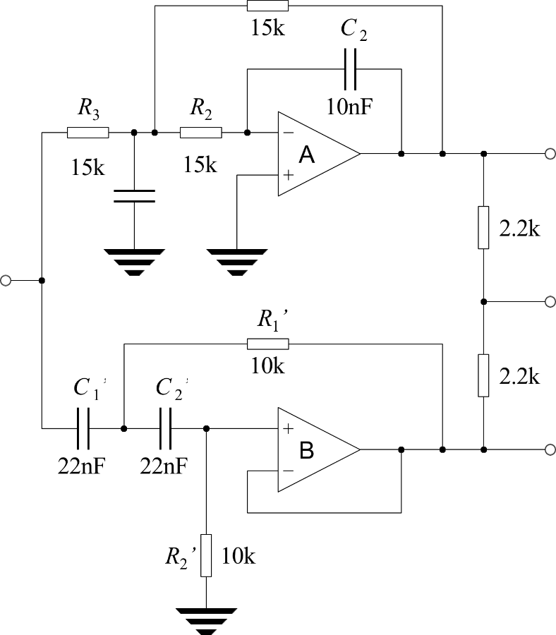

Sub-heading as required

- Study 1 – Change this title!
The layout in this section is Theory, Methods, Study 1, Study2, Study 3 but this may not suit your project! You can change this sections to whatever you need.

Aims

Methods

Results
The caption for the Table 1 below is setup using Words cross referencing feature. If you mouse over the “Table 1” in the sentence above it will allow you to follow a link to the Figure. The cross-referencing feature allows you to refer to the figure in-text (like your referencing manager) and Word will update figure numbers as required.

Table 1 Fraction of air volume involved in heat exchange for second mode (right column) vs. filling factor (left column). The plain-text headings represent f, m, µ2 and f2.
f(%) | m | µ2 | f2 (%)
0.016 | 80.00 | 0.05400 | 4.874
0.031 | 56.57 | 0.07732 | 5.438
0.062 | 40.00 | 0.11103 | 6.125
0.125 | 28.28 | 0.16001 | 6.970
0.250 | 20.00 | 0.23175 | 8.020
0.500 | 14.14 | 0.33799 | 9.329
1.000 | 10.00 | 0.49789 | 10.967
2.000 | 7.07 | 0.74444 | 13.008
4.000 | 5.00 | 1.13919 | 15.525
8.000 | 3.54 | 1.81095 | 18.568
19.237 | 2.28 | 3.61958 | 23.174
37.180 | 1.64 | 7.28635 | 27.094
57.392 | 1.32 | 14.63631 | 29.813
74.316 | 1.16 | 29.35160 | 31.453
85.734 | 1.08 | 58.79364 | 32.360

Discussion

- Study 2- Change this title!

Aims

Methods

Results

Discussion

- General Discussion and Conclusions

Summary

Discussion

Conclusions

Future Word

References
Use your reference manager to insert references in the text and then generate this list automatically. Check all the references as they are printed below to ensure they are complete and correct.
- L. Lamport, LATEX: A Document Preparation System, 2nd ed. (Addison-Wesley, 1994).
- REFERENCE 2
- Etc.

Appendix A
Appendices are useful for supplying necessary details or explanations which do not seem to fit into the main text, perhaps because they are too long and would distract the reader from the central argument. Appendices are also used for program listings. Notice that appendices are “numbered” with capital letters, not numerals. When the \appendix command in LATEX [1, p. 175] is used with the book document class, it causes subsequent chapters to be treated as appendices.

